Business Data Analytics Project: Guidelines

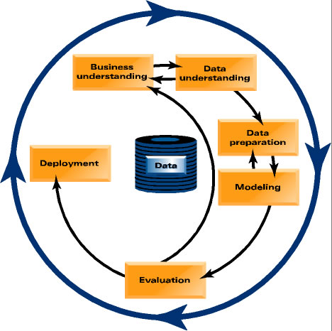
Effective data analytics thinking should allow you to assess potential business data analytics projects systematically. This set of proposal guidelines contain key questions that one should have in mind when considering a data analytics project. The questions are framed by the data analytics process discussed in class, and used as a conceptual framework throughout the semester. You should be able to apply these conceptually to a new business problem. The list of questions that follow is not meant to be exhaustive. However, the list contains a selection of some of the most important questions to ask. Throughout the semester we concentrate on data analytics projects where the focus is to mine some regularities, patterns, or models from the data. The set of proposal guidelines reflects this.

To start this project, you should write a formal business memo that answers the following sectional questions:
- Business and Data Understanding
- Describe the business/organization that has been chosen as a case study.

- An idea of what the team wants to do with this organization. At a high level the team may want to answer the following questions:
  - What is the business problem/opportunity that you are trying to address?
  - What data analytics solution are you developing and implementing?

- Is the problem a supervised or unsupervised problem (You should focus on supervised problem, which is the major focus of the course)?
  - If supervised,
    - Is a target variable defined?
    - If so, is it defined precisely?
    - Think about the values it can take.
  - Are the attributes defined precisely?
    - Think about the values they can take.

- For supervised problems: will modeling this target variable improve the stated business problem?

- Does framing the problem in terms of expected value help to structure the subtasks that need to be solved?

- Data Preparation
- What is your data source (i.e., How will you collect/obtain data to perform the project, Are there any costs taken into account in the process, etc.)?
- Will it be practical to manipulate your data, get values for attributes and create feature vectors, and put them into a single table?
- If not, is an alternative data format defined clearly and precisely? Is this taken into account in the later stages of the project?
- If the modeling will be supervised, is the target variable well defined? Is it clear how to get values for the target variable (for training and testing) and put them into the table?
- How exactly will the values for the target variable be acquired?
- Are the data being drawn from the similar population to which the model will be applied? If there are discrepancies, are the selection biases noted clearly? Is there a plan for how to compensate for them?

- Modeling
- Is the choice of model appropriate for the choice of target variable?
  - Classification, class probability estimation, regression, etc.

- Does the model/modeling technique meet the other requirements of the task?
  - Generalization performance, amount of data required, type of data, missing values?
  - Is the choice of modeling technique compatible with prior knowledge of problem?

- Should various models be tried and compared (in evaluation)?

- Evaluation and Deployment
- Is there a plan for domain-knowledge validation?
  - Will domain experts or stakeholders want to vet the model before deployment?
  - If so, will the model be in a form they can understand?

- Is the evaluation setup and metric appropriate for the business task?
  - Are business costs and benefits taken into account?
  - For classification, how is a classification threshold chosen?
  - Are probability estimates used directly?
  - For regression, how will you evaluate the quality of numeric predictions? Why is this the right way in the context of the problem?

- Does the evaluation use holdout data?
  - Cross-validation is one technique.

- Against what baselines will the results be compared?
  - Why do these make sense in the context of the actual problem to be solved?
  - Is there a plan to evaluate the baseline methods objectively as well?

- Will deployment as planned actually (best) address the stated business problem?

- If the project expense has to be justified to stakeholders, what is the plan to measure the final (deployed) business impact?

- Project identifying information: You should create a project charter that includes the following project identifying information:
- Project Name
- Project Manager (designate one from your team as the primary contact)
- Project Start/End dates
- Any other stakeholders the project may involve
- Project overview (One or two paragraphs)
- Objectives (One brief paragraph)
- Key assumptions (If any applicable)

For more information and instructions, you may want to refer to Chapter 13, Appendix A, and Appendix B of the textbook, Provost, F. & Fawcett, T. (2013). Data Science for Business: What You Need to Know about Data Mining and Data-Analytic Thinking (1st Edition), O’Reilly.

